**II. The second case: φd(σ) = 0 and I(σ) is asymmetric.**

To simulate the spectral distribution of an actual light source, the distribution of *I*(*σ*) is asymmetric with a weighted average wavenumber *σA*. The distribution of *I(σ)* is shown in Fig.1(a). The weighted average wavenumber *σA* is defined as



In order to obtain a more realistic and asymmetric spectral distribution *I(σ)*, here *I(σ)* is obtained by performing multi-order Gaussian fitting of the actual spectrum. *I(σ)* can be expressed as



IFT of *Gi(σ)* is defined as 



So,





From Euler’s formula we can get the intensity and phase distribution of *SC(z)*,





Where *L=2(z-zO)* and .

Owing to *Si(L) = -Si(L)*, the intensity distribution *A(L)* is evenly symmetric about L= 0 and phase distribution *α(L)* is oddly symmetric about L= 0. According to the Eq.(15), the peak position in the amplitude distribution of *SC*(*z*) is *za=zo*, and the zero phase position nearest z=*za* is *zp=zo*. Similarly, according to the Eq.(10), the period P of the unwrapped phase distribution is almost equal to *1/2σA*=*λA*/2.

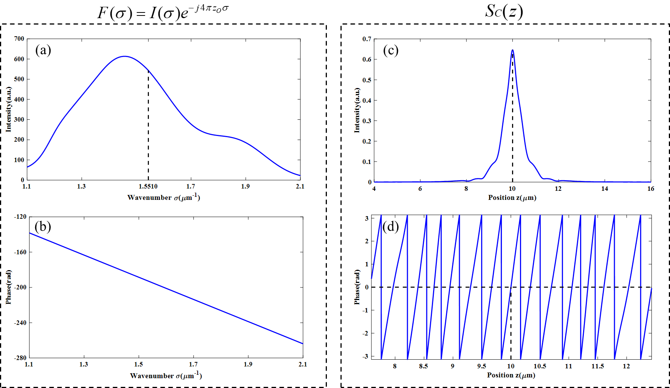



(e)

unwrap

Fig. 4 IFT (Inverse Fourier transform) of *F(σ)*. (a) The intensity of *F(σ)*. (b) The phase of *F(σ)*.

(c) The intensity of *SC(z)*. (d)The phase of *SC(z).* (e) The unwrap phase of *SC(z).*

Fig.4 shows the simulation about the IFT(Inverse Fourier transform) of *F(σ)*. Fig.4(a) shows the intensity of *F(σ)*. The interference signal in wavenumber domain is generated in the region from 1.1 μm-1 to 2.1 μm-1 where the weighted average wavenumber *σA* is 1.5510 μm-1 , and the sampling interval ∆σ and the sampling number are 0.00092 μm-1 and 65535, respectively. The phase of *F(σ)* as shown in Fig.4(b) in which the value *zO*is 10 μm. The intensity and phase of *SC(z)* which is IFT(Inverse Fourier transform) of *F(σ)* as shown in Fig.4(c) and Fig.4(d), respectively. Amplitude of the interference signal is shown in the region from 4 μm to 16 μm where the value za is 10.0009 μm, as shown in Fig.4(c). The other data outside this region almost are zero values. In the Fig.4(d), phase of *SC(z)* is wrapped between -π to π and the value of zp is 10.0009 μm which is equal to za. After unwrapping the phase as shown in Fig.4(e), it is found that the phase is nonlinear and the nonlinear component as shown in Fig.5. In Fig.4(e), the zero rad in the unwrapped phase is near to z=za. [It is important to describe the reason why Fig.4(e) contains the nonlinear component with sentences, not with equations. Please describe this reason.] The relevant parameters of *F(σ)* and simulation results of *SC(z)* are shown in Table 3 and Table 4. [Please show the nonlinear component of Fig.4(e) by calculating {Fig.4(e) - least square line of Fig.4(e)}. ] {Fig.4(e) - least square line of Fig.4(e)} is shown as Fig.6.

Table 3. The relevant parameters of *F(σ)* and *SC(z).*

|  |  |  |
| --- | --- | --- |
| σA | zO | λA |
| 1.5510μm-1 | 10μm | 0.6447μm |

**Table 4. Simulation results shown in Figs.4 (c) and (d).**

|  |  |  |  |
| --- | --- | --- | --- |
| za | zp | P | P-λA­/2 |
| 10.0009μm | 10.0009μm | 0.3317μm | 0.0094μm |

[P=*λA*/2=0.3223μm, but its simulation value is 0.3288μm. What is the reason of the difference of 0.3288-0.3223=0.065μm?]

A large error occurred when the period P was calculated last time. Due to sampling reasons, the abscissas corresponding to the phases π and -π cannot be accurately calculated, so the abscissas corresponding to the π and -π phases are calculated through interpolation, and then the period P is calculated by subtraction. The inspection revealed that the abscissa error calculated through interpolation was too large. After increasing the number of sampling points, the abscissas of the phase π and -π can be obtained more accurately, as shown in Figure 5.

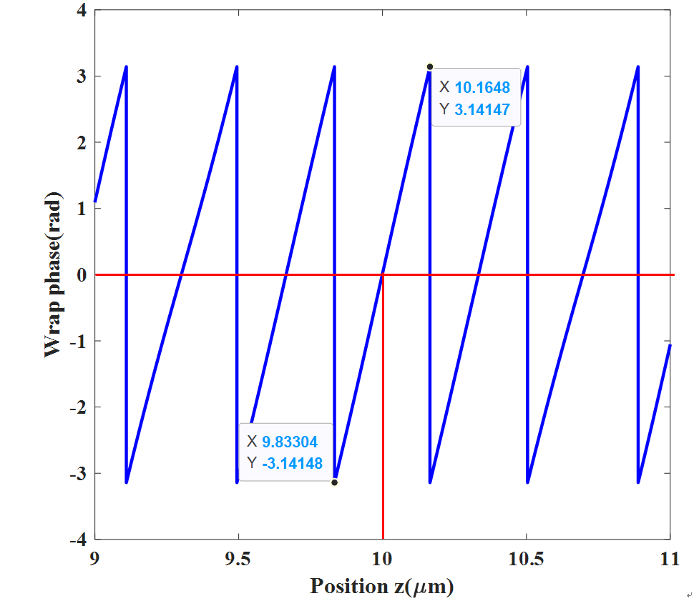

Fig. 5 Calculate period value.





Fig. 6 Unwrap phase, least squares lines of unwrap phase, and the nonlinear component of unwrap phase.